How to Link My Business

Disclaimer
The information in this manual is for educational and informational purposes only and does not constitute legal advice. Information is presented as an overall review that is subject to law changes and may not apply to all states.
Information in this manual is believed to be accurate as of the date of publication. In the event that any information in this manual is later determined to be in error, this manual cannot be used by taxpayers in supporting a specific position or issue before the Department of Revenue, as it does not have the statutory or regulatory authority.

How to Link My Business
(Updated 7/29/19)
Log in to your One Stop account.
- Go to www.onestop.ky.gov
- Click on the One Stop Business Services Icon.
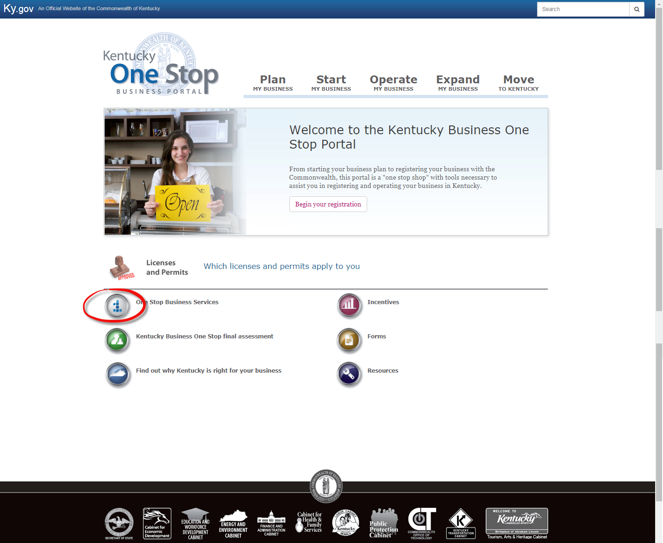

- Type in your email address and password and click Sign in.

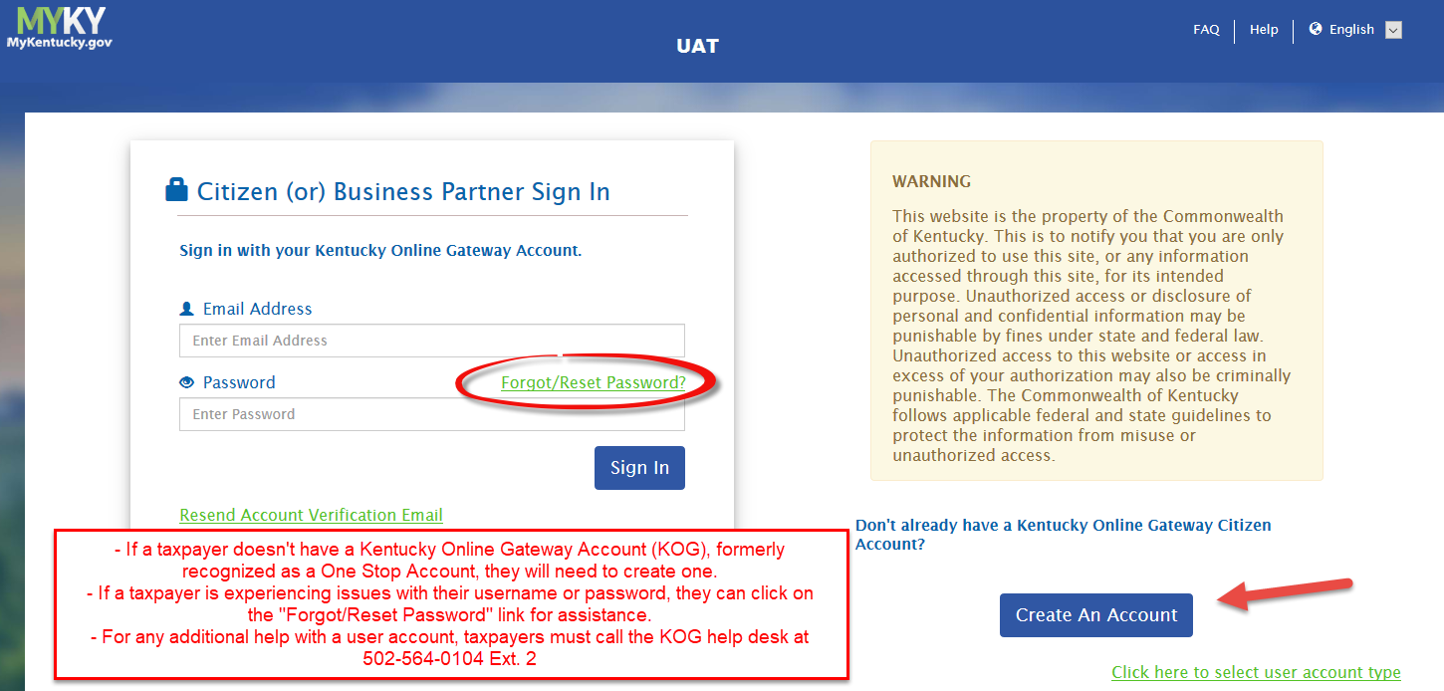

4. Once on the KOG dashboard click on Launch or Enroll that is within the Kentucky Business One Stop tile. This will take you to the Kentucky Business One Stop Dashboard where you can link your business.

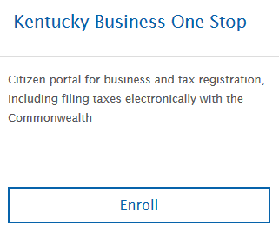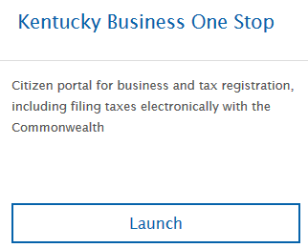

Multiple businesses may be linked to the same user account. To link a business, click on ‘Link My Business’.
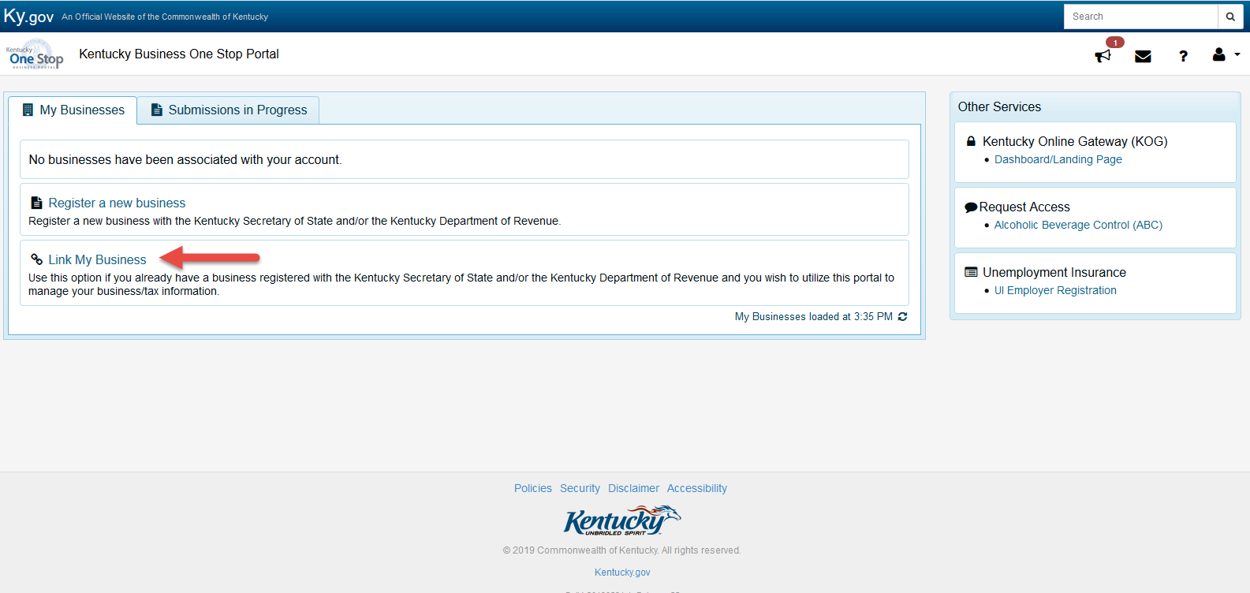

Next, type in the CBI Number, Business Name (Business Name must be typed exactly as it is on SOS or in DOR records, this includes punctuation and spacing), and the Security Token.
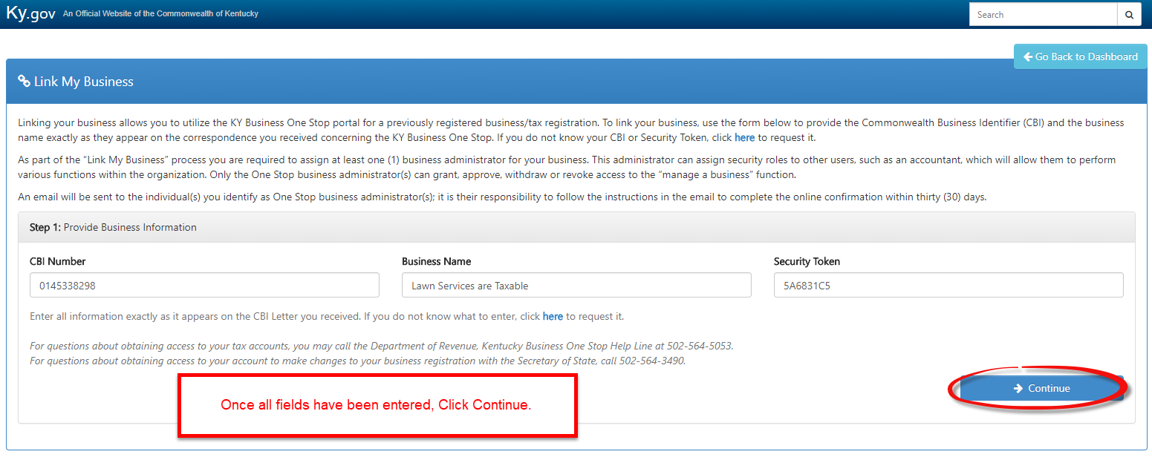

If the business has an active account that is already enrolled for online filing, Step 2 will be adding the One Stop Business Administrator. The user can check the box to make themselves the One Stop Business Administrator and/or add an additional admin and then select Send Invite. (CPA’s or accountants should not make themselves the Administrator, that role should be assigned to someone from the business.)
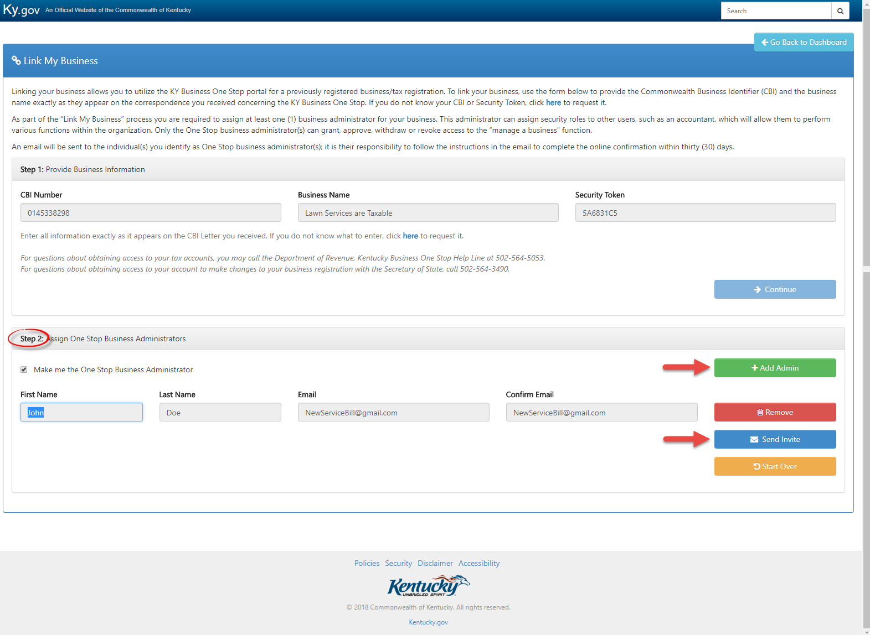
Once the user adds the One Stop Business Administrator, click Go to Dashboard.
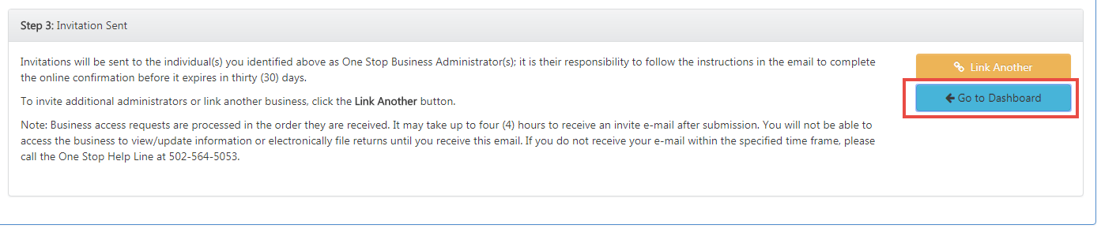
If the business has an active Sales tax account that is not enrolled for online filing. Step 2 will ask the user if they want to enroll for online filing. Click continue to move forward to add the One Stop Business Administrator.
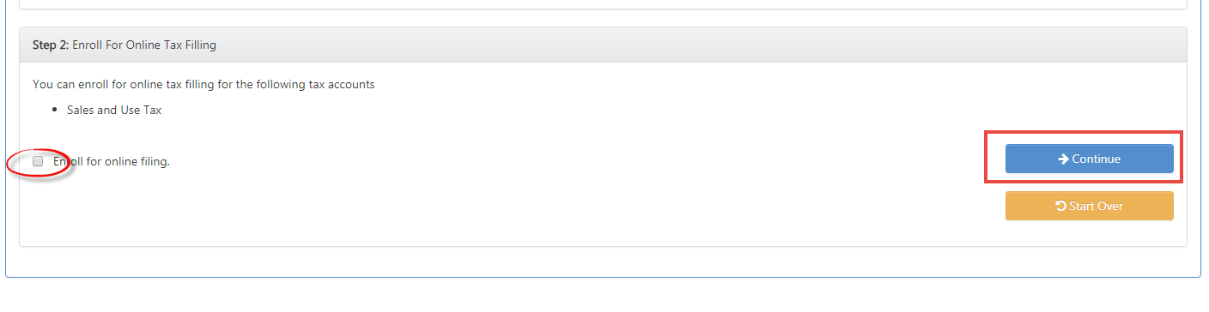
If the user is assigning themselves the role of One Stop Business Administrator, they should go back to the Dashboard and the business should be available under the My Business Grid.
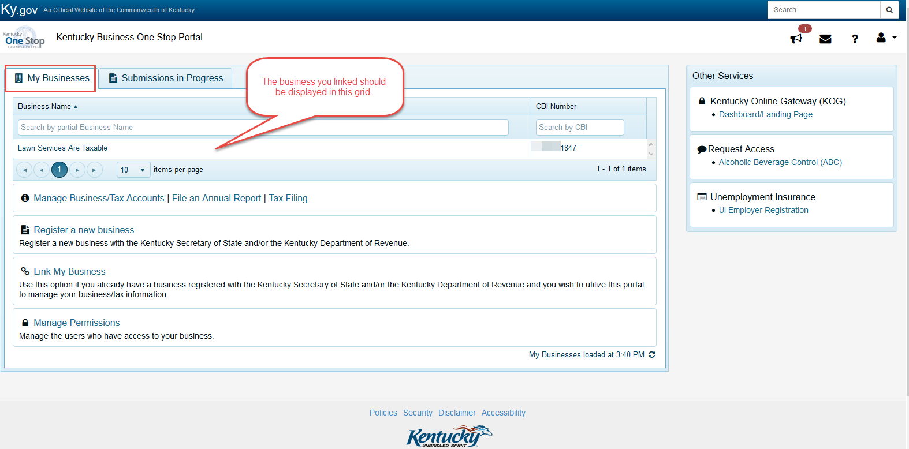

For additional users who were sent an invite, they will need to go to their email and follow the instructions within the email. Below is an example of the email.
